Assesment:- Consider a scenario in which you have to create a table called Nobel_win where you have given the information about the entity who has achieved nobel prize in a particular subject all over the world. Over here the table Nobel_win will contain attributes like year, subject, winner, country and category

Ans:-

create database Asses3;

use Asses3;

create table Nobel_win(YEAR integer,

SUBJECT text,

WINNER text,

COUNTRY text,

CATEGORY text);

select * from Nobel_win;

insert into Nobel_win(YEAR,SUBJECT,WINNER,COUNTRY,CATEGORY)VALUES

(1970,'Physics','louis Neel','France','scientist'),

(1970,'Chemistry','luis Federico Leloir','France','scientist'),

(1970,'Physiology','Ulf von Euler','Sweden','scientist'),

(1970,'Physiology','Bernard Katz','Germany','scientist'),

(1970,'literature','Aleksandr Solzhenitsyn','Russia','Linguist'),

(1970,'Economics','Paul Samuelson','USA','Economist'),

(1970,'Physiology','Julius Axelrod','USA','scientist'),

(1971,'Physics','Dennis Gabor','Hungary','scientist'),

(1971,'Chemistry','Gerhard Herzberg','Germany','scientist'),

(1971,'peace','Willy Brandt','Germany','chancellor'),

(1971,'Literature','Pablo Neruda','Chile','Linguist'),

(1971,'Economics','Simon Kuznets','Russia','Economist'),

(1978,'Peace','Anwar al-Sadat','Egypt','President'),

(1978,'peace','Menachem Begin','Israel','prime minister'),

(1987,'chemistry','Donald J. Cram','USA','Scientist'),

(1987,'Chemistry','Jean-Marie Lehn','France','Scientist'),

(1987,'Physiology','Susumu Tonegawa','Japan','Scientist'),

(1994,'Economics','Reinhard Selten','Germany','Economist'),

(1994,'Peace','Yitzhak Rabin','Israel','Prime Minister'),

(1987,'physics','Johannes Georg Bednorz','Germany','Scientist'),

(1987,'Literature','Joseph Brodsky','Russia','Linguist'),

(1987,'Economics','Robert Solow','USA','Economist'),

(1994,'Literature','Kenzaburo Oe','Japan','Linguist');

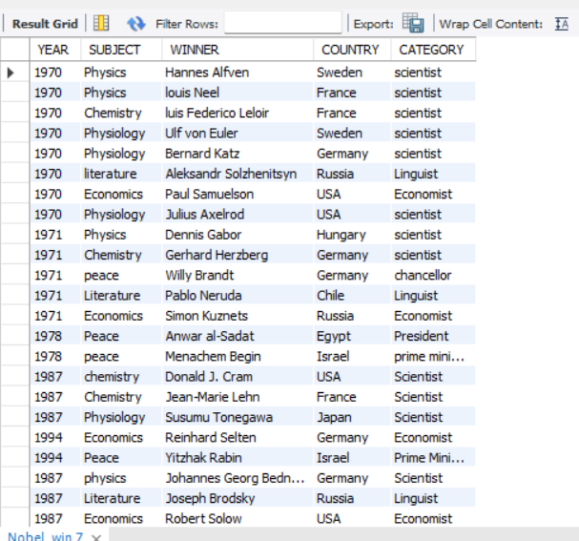

Q-1: Write sql query to find the nobel prize winners of the year 1970. Return year,subject and winner.

Ans:- select YEAR,SUBJECT,WINNER from Nobel_win where year=1970;

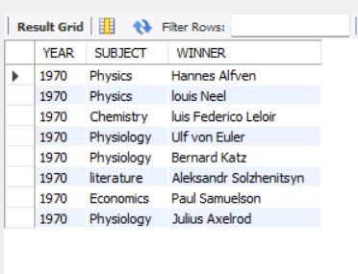

Q-2: Write sql query to find the nobel prize winners in chemistry between the years 1965 and 1975. Begin and end values are included Return year, subject, winner and country

Ans:- select YEAR,SUBJECT,WINNER,COUNTRY from Nobel_win where YEAR between 1965 and 1975 and SUBJECT='Chemistry';

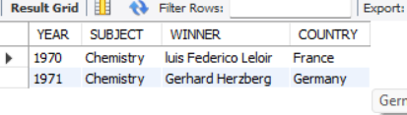

Q-3: Write sql query to retrieve the details of the winners whose first name matches with the string ‘Louis’. Return year,subject,winner,country.

Ans:- select YEAR,SUBJECT,WINNER,COUNTRY from Nobel_win where winner like'Louis%';

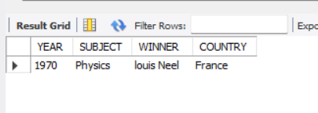

Q-4: Write sql query to find Nobel prize winners for the subject that does not begin with the letter ‘P’. Order the result by year, descending and winner in ascending.

Ans:- select YEAR,SUBJECT,WINNER,COUNTRY FROM Nobel_win where SUBJECT not like'p%' order by YEAR DESC, WINNER ASC;

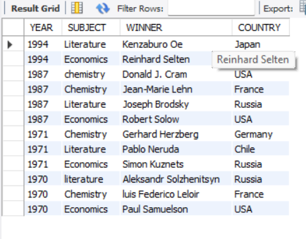

Q-5: Write sql query to find the details of 1970 Nobel prize winners. Order the result by subject, ascending except for ‘Chemistry’ and ‘Economics’ which will come at the end of the result set. Return year, subject, winner , country and category.

Ans:- select YEAR,SUBJECT,WINNER,COUNTRY,CATEGORY FROM Nobel_win Where YEAR=1970 order by CASE WHEN SUBJECT IN('Chemistry','Economics')then 1 else 0 END,SUBJECT ASC;

